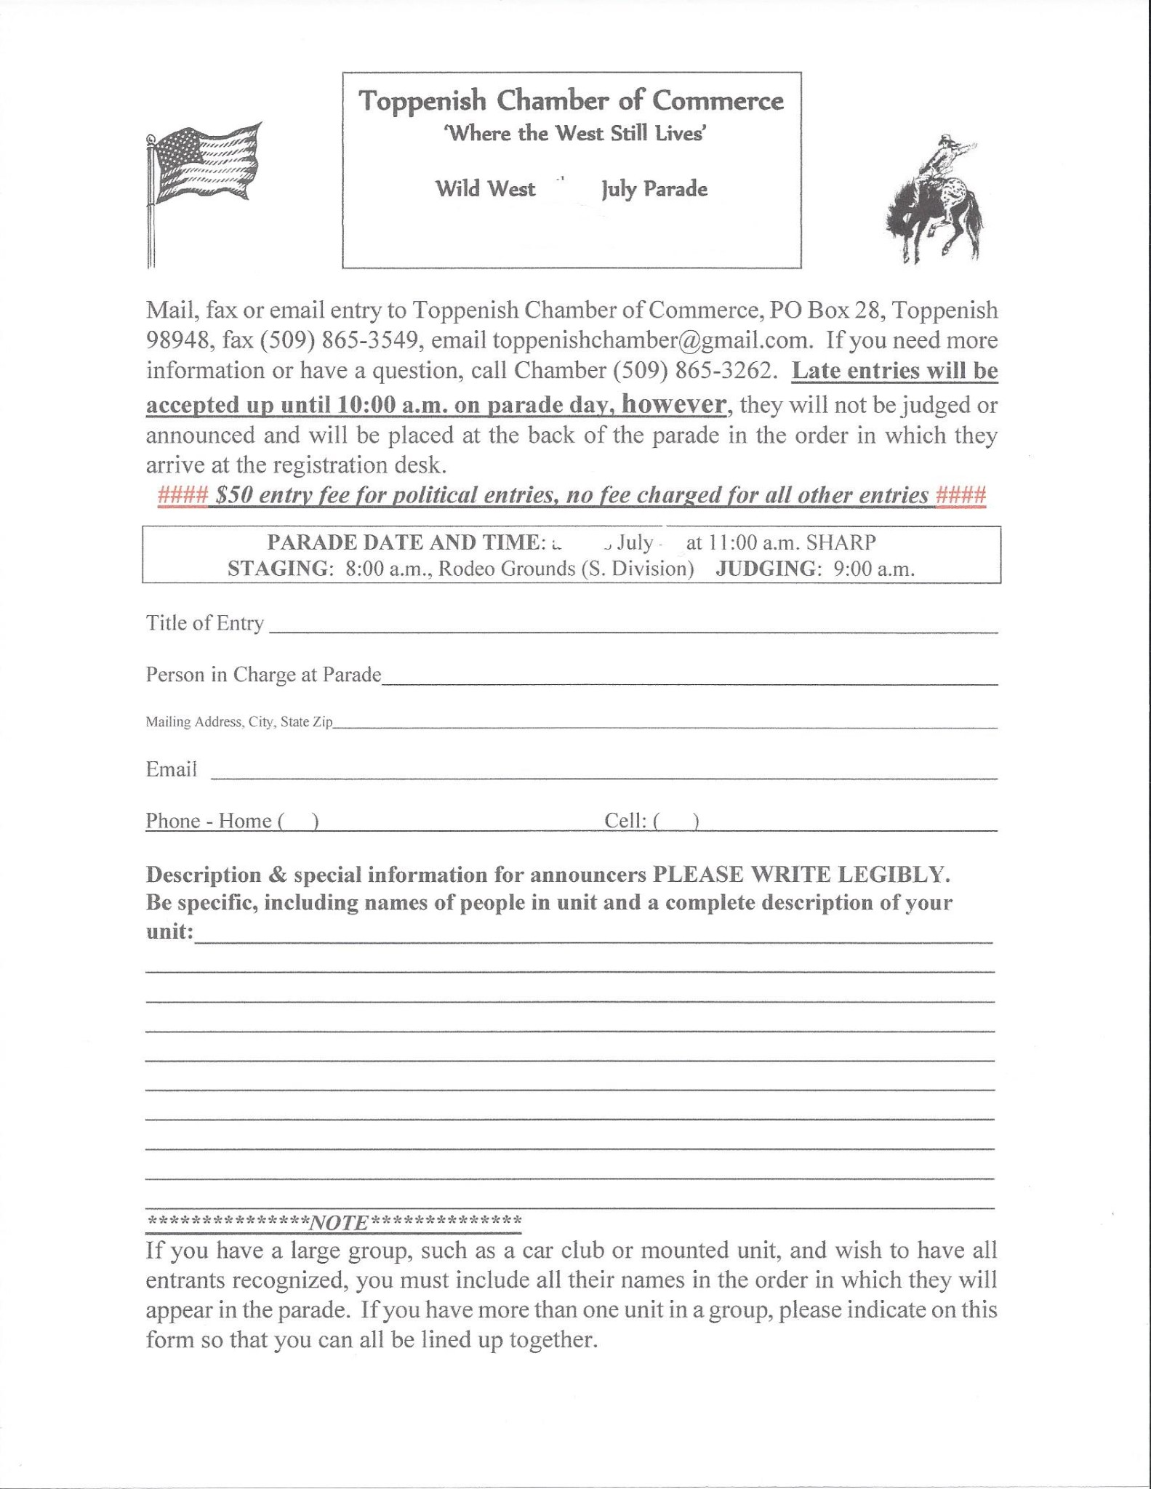

**SATURDAY July 4th 2020**

4

th

$ **75**

**XXXXXXXXXXXX**

xxxx

